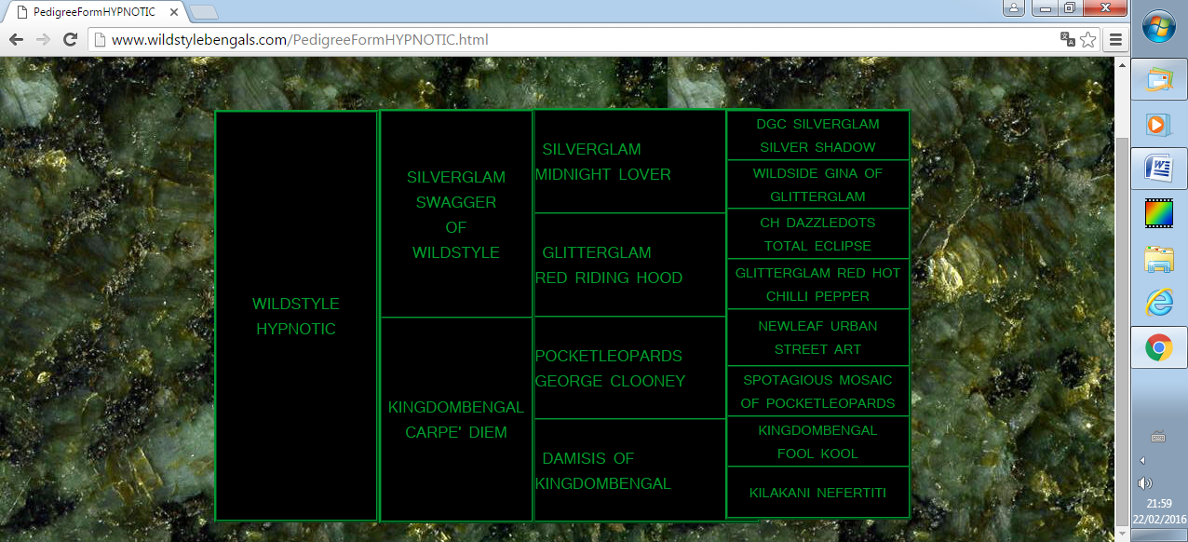Dam WildStyle

Père-Father

Legacie Northen Lights

Medoz Misty Spirit

Indiancreek Cocomo of Naples

Amantra Apache Princess

Naples Moxie

Juniperridge Apache Tears

Legacie Electrifying

Amantra Sorcia of Callista

Amantra Reigning Comets

Amantra Legacie made of Callista

Amantra Jack Frost of Naples

Naples

Sogni D’Oro

Of WildStyle

Pocketleopards Sage

CH Medoz Chill Factor

Legacie Legacy of Naples

Galaxy

of Kingdombengal

Pedigree

Mère-Mother