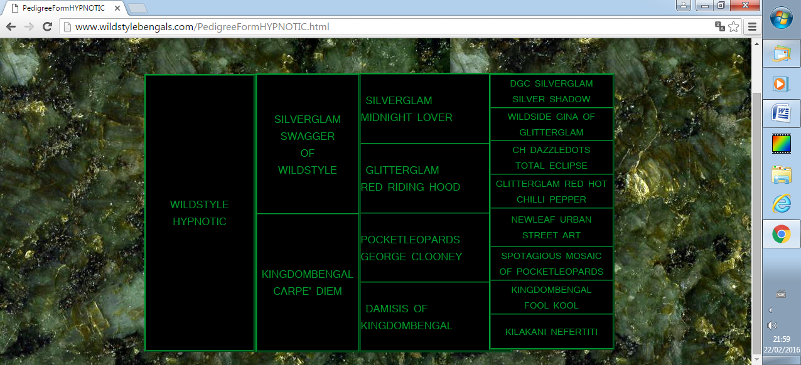Sir Kingdombengal

DRINKWATER CLOUD REFLECTION

PURRECIOUSPOTS PETRA

RISNSUN CHARM Of DRINKWATER

RW QGC THEREALMS GIGOLO

CH KOPPIEKATZ KADILLAC

DRINKWATER TOPAZ Of KOPPIEKATZ

KOPPIEKATZ DON JUAN

Père-Father

TIDAL WAVE

ABUNDADOTS JUNGLE PRINTZ

POCKETLEOPARDS WILDSTYLE

POCKETLEOPARDS METALLIC MISS

RW TGC JUNGLEBOOK NATIVE SON

Kingdombengal

Total Eclipse

KATZNJAMR'S CHILUKKI

ABUNDADOTS AZTECA

Black Diamond

BENGALIVO ARAMIS Of KANPUR

ANJALI TITANIC SEDUCER

KANPUR KIKI

Kanpur Montana

of Kingdombengal

KANPUR AKEILA

TRENDAR FLASH

SILVERSTORM AMAZING SECRET

Pedigree

ABUNDADOTS TEQUEEZA

NAAMAH GRAFFITI ART

KINGSMARK SUTTARA

GRANITEBENGALS ICE DANCER

JUNGLEBOOK MADE IN THE USA

Pocketleopards Zorro

Abundadots

Rakcha

DAZZLEDOTS ONYX ON ICE

Mère-Mother